CST8002 – Programming Language Research
Practical Project Part 02 (Python)
Name: Varshil Patel
Student Number: 041142255
Section: 010
Professor: Stanley Pieda
Date: 16-11-2025

Evidence of Learning
The given practical project is the continuation of the initial part of the course that involves applying a layered architecture to process the Pacific Rim Forest Mammal Populations data in Python. The program shall load streams containing 100 rows of the CSV file into memory and the user will be able to view, add, edit, delete and save record through the help of a menu driven interface. Variables, functions and control structures in Python that I used to develop the menu system are if/el if decisions, and while loops.
The data is stored in memory as lists of Record objects, and all the objects are easily related to the data set columns (site identification, lure type, species common name, number of individuals field and date/time field). Record class is used to implement simple data type, identifiers and counts are implemented as integers, and other values are implemented as strings. Persistence layer: File input and file output are supported using the csv and pathlib libraries. The initial dataset to be used in the program is in data/dataset.csv and it is read at the beginning of the program and can be written to a new CSV file that would contain the changes made in the process of running the program. In case the dataset file is not located, a try/except statement will be used to manage the FileNotFoundError. In the case where the numbers are not convertible, the try/except block caters to the ValueError.
This increases the practical knowledge of the program. The program uses the uuid library as an illustration of how external libraries and APIs can be used in order to generate unique names of files in saving the altered records. After each Save operation, a new CSV file is generated with the UUID in the name so that the older versions are not overwritten.
Finally, I employed simple unit test to make sure that the add record method in the business layer functions as it would through Python unittest. The test repeats the data, adds another Record and ensures that the total records are one. Although the number of the tests applied in this project is not great, it shows how automated testing can be abused in the development process to ensure the greater trust in the behaviour of the program.

Program Architecture

The application has been designed around a layered architecture such that they are data, logic and user interface concerns. There is a distinct responsibility and each layer can be changed or tested separately.

Model Layer The record class in model/record.py is a single row of the Pacific Rim forest mammal data. Attributes are equivalent to dataset columns with the identification of a site, camera set and check date-times, lure type, common name of a species, the number of individuals, and observation date-time.

Persistence Layer -Persistence/repository.py contains the persistence code that does the reading of the CSV files as well as the writing of the same. The load records function employs the csv module which reads a maximum of 100 records of data/dataset.csv, and transforms them into Record objects. Save records function records the records in the memory to a new CSV file whose name is created with the help of uuid.uuid.

Business Layer Business/service.py provides the implementation of the business logic. This layer contains the memory of a list of the Record objects and offers the functions to reload, read and carry out CRUD (create, read, update, delete) operations. It also checks the indices, checks them with status of validity prior to updating or deleting records, such that invalid indices do not crash the program.

Presentation Layer- The user interface in form of a console is applied in the presentation/menu.py. The run () function presents a menu where a user has to reload, view, create, edit, delete and save records. Here all the interaction with user (input and output) is done. The menu invokes the business layer functions and makes my full name, Varshil Patel to appear prominently every time to make people recognize the output of the program as my work.

sTest Layer- There is a unit test of the service layer in the tests/test_service.py file. The tests can be separated into a separate package and can therefore be easily executed using the python -m unittest command without any effect on the main program.

Package Diagram
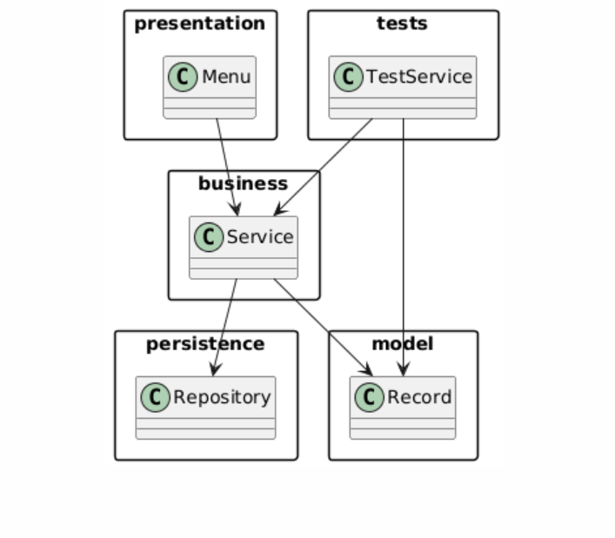

Class Diagram
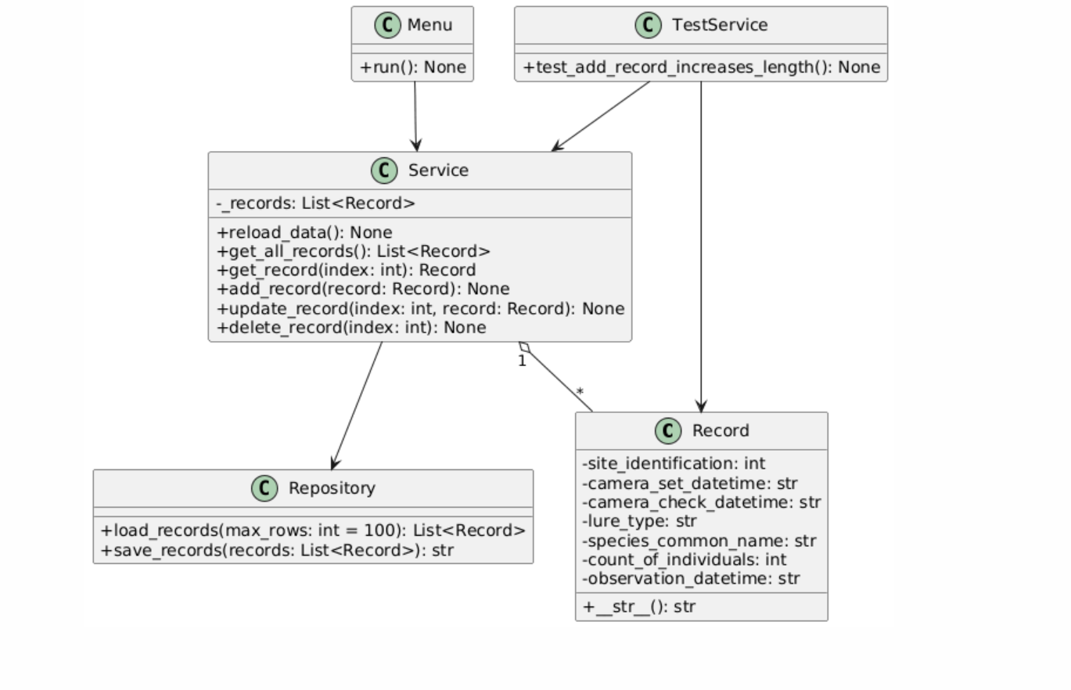

Sequence Diagram
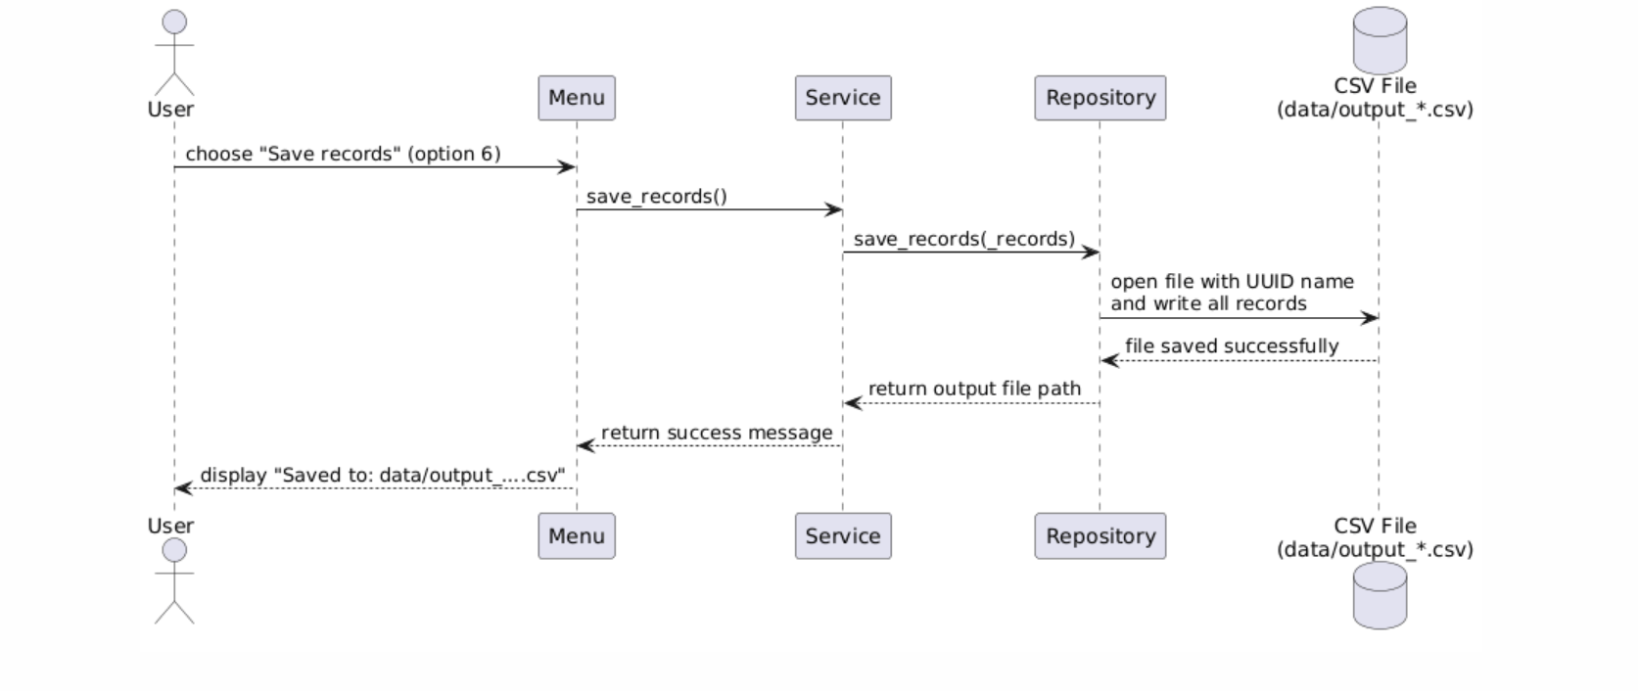

Program Demonstration via Screen Shots

Program Startup Screen
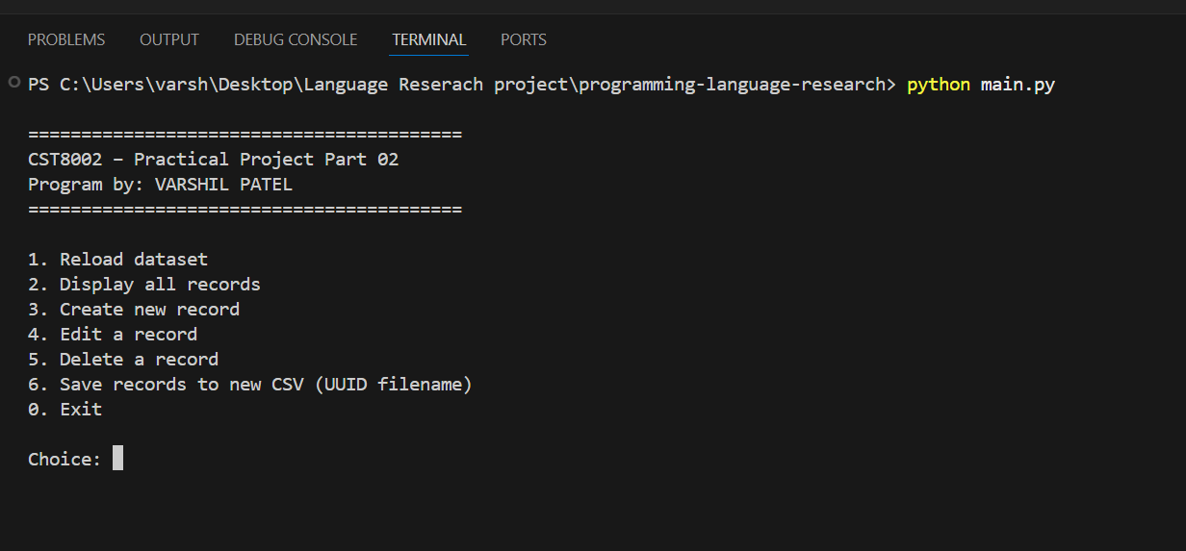
Description: Program gets started and shows the menu list.

Reload Dataset
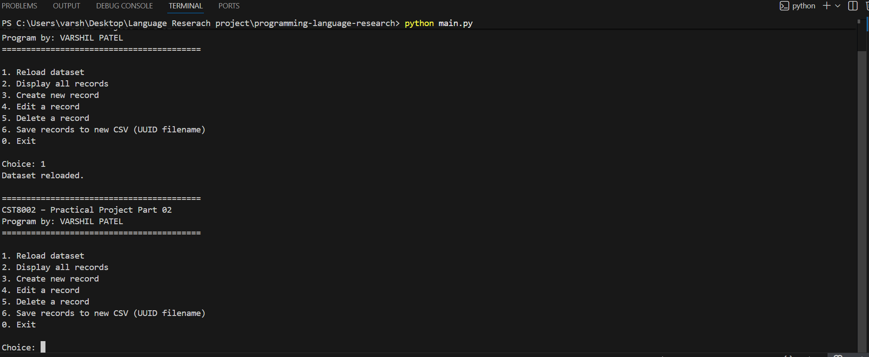
Description: Dataset gets reloaded

Display All Records
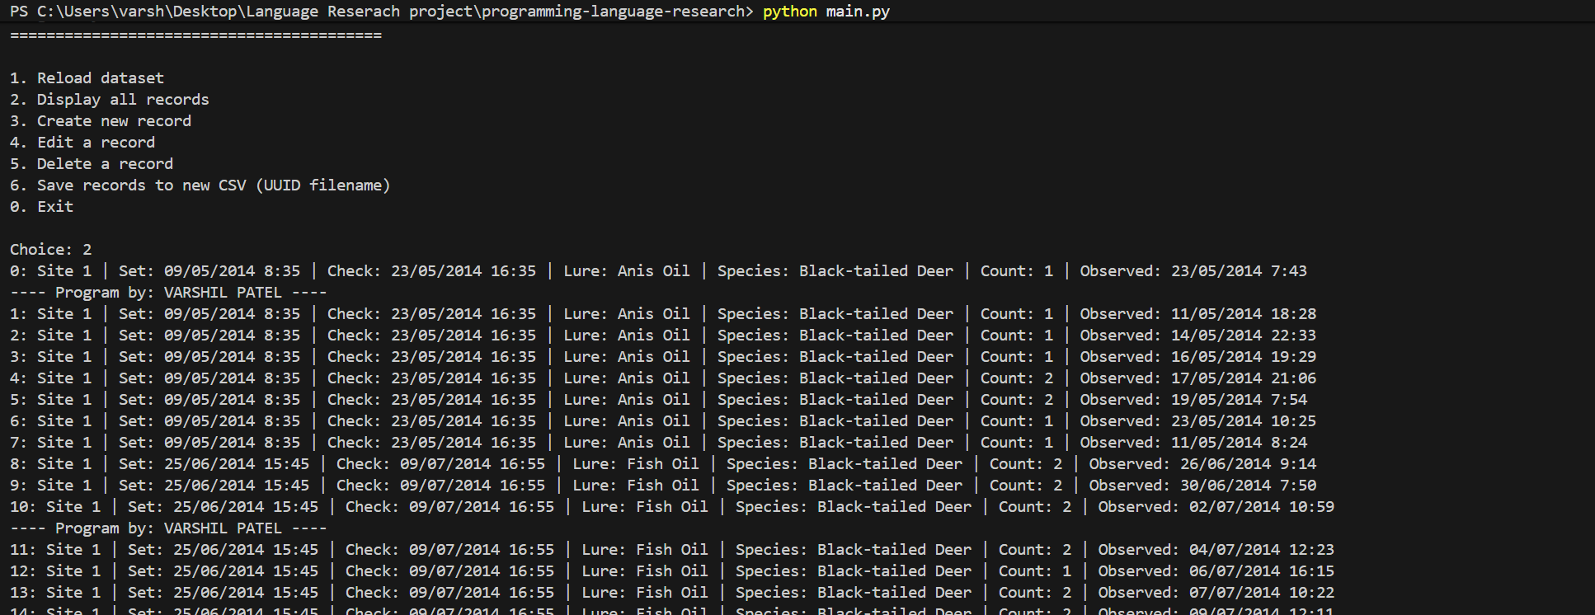
Description: The display option prints several records from dataset. Every 10 records, the program prints my name to clearly label output.

Create New Record
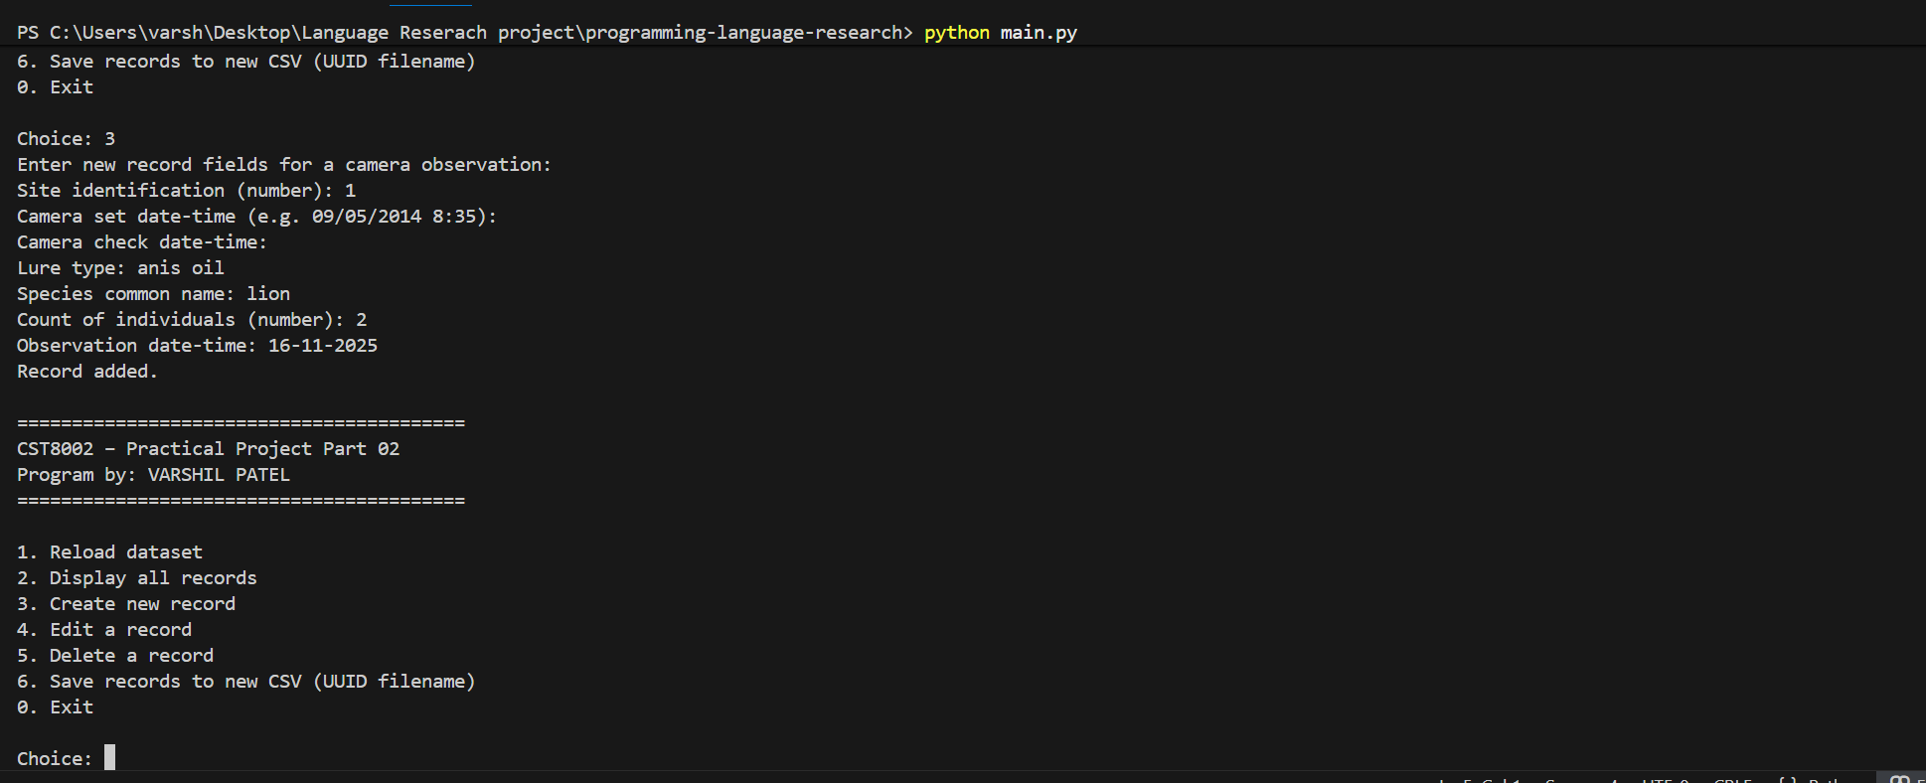
Description: I added test observation by entering the details. The program confirms that the record was added.

Edit Record
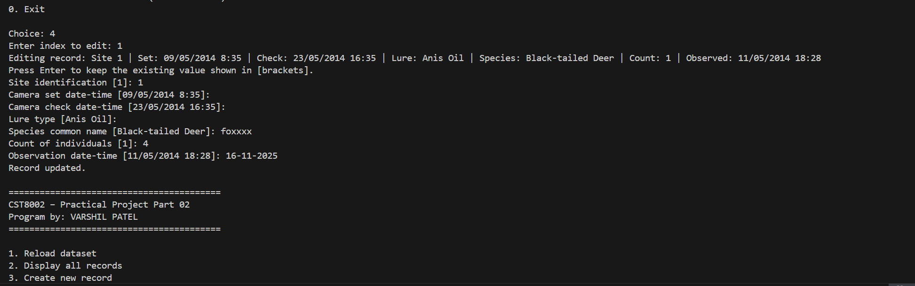
Description: I selected the index of the test record and changed one or more fields. The program

Delete Record
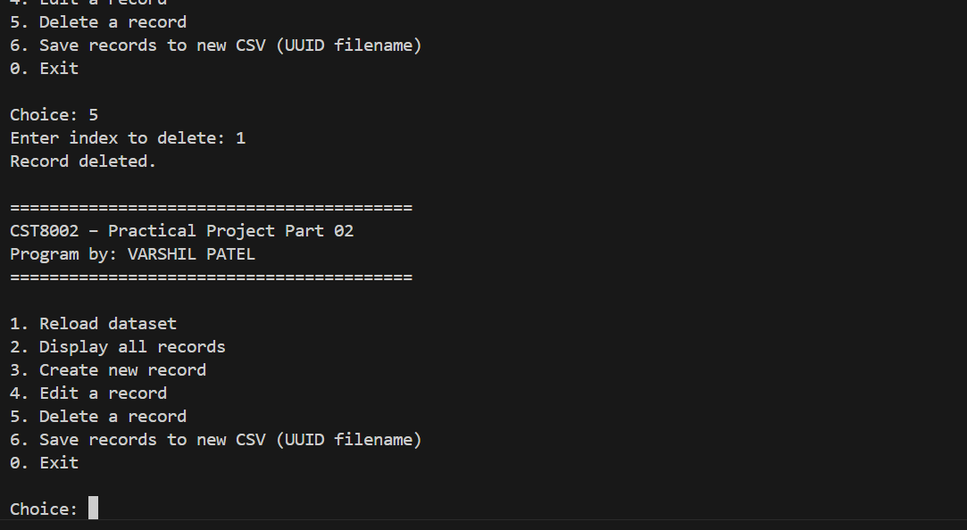
Description: After testing, I deleted the test record using the delete option and confirmed that it no longer appears in list.

Save Records (UUID Output)
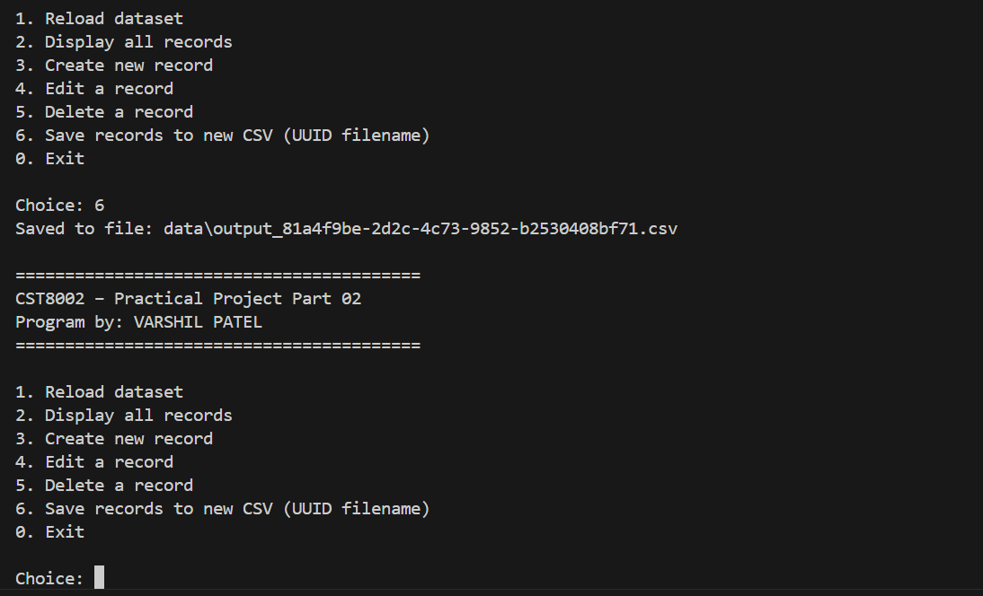
Description: The save option writes all current records into new csv file in the data folder. The file name include UUID so that each run of the program creates a unique output file.

Exit Program
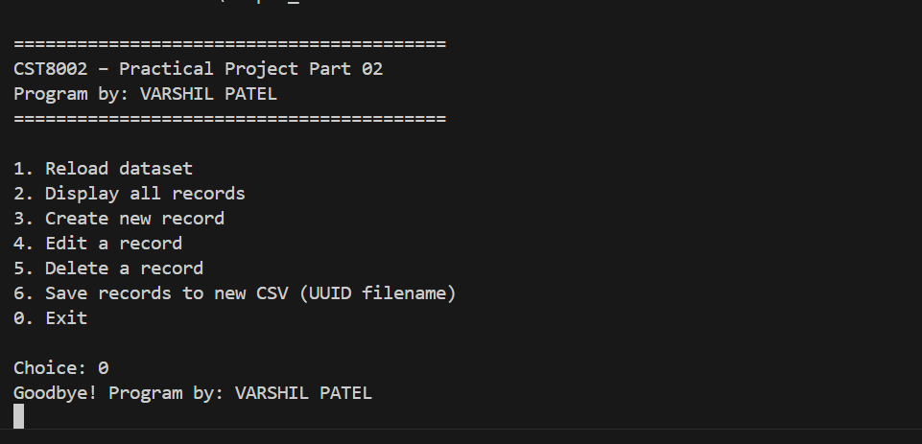
Description: The exit option ends the loop, prints a goodbye message with my name, and returns control to terminal.

Unit Testing Screenshot

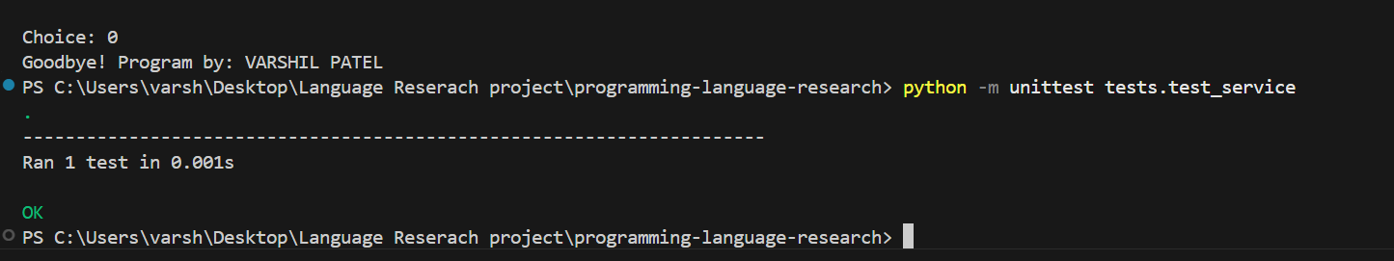
Description: This screenshot shows the result of running unit test. The test case test_add_record_increases_lenghth reloads the dataset, adds a new record, and asserts that the total number of records has increased by one. The “ok” result indicates the business logic for adding records is working as they are excepted.

References
[1] Python Software Foundation, “Python 3 Documentation,” Python.org. Available online: https://docs.python.org/3/
[2] Python Software Foundation, “csv — CSV File Reading and Writing,” Python.org. Available online: https://docs.python.org/3/library/csv.html
[3] Algonquin College, “CST8002: Practical Project Guidelines,” School of Advanced Technology, 2025.
[4] Python Software Foundation, “unittest — Unit testing framework,” Python.org. Available online: https://docs.python.org/3/library/unittest.html
Appendix – AI Use
I used ChatGPT as a writing assistant to help me organize my thoughts, correct grammar, and structure this report. All program code, screenshots, and final decisions about wording and content were created and verified by me, and I take full responsibility for the work submitted.

